**EBS**

1. CREATE INSTANCES

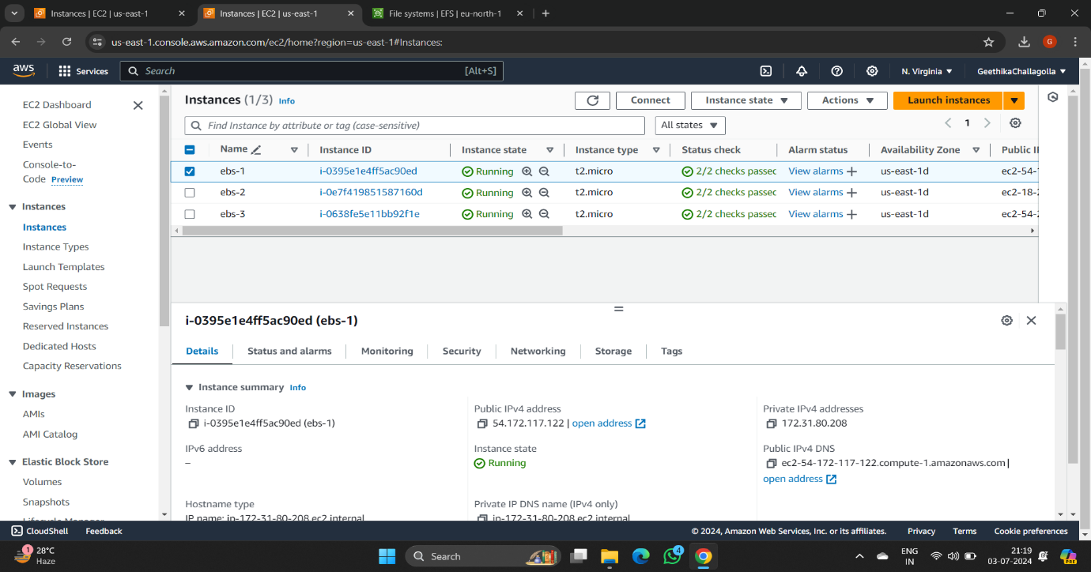

1. CREATE VOLUME

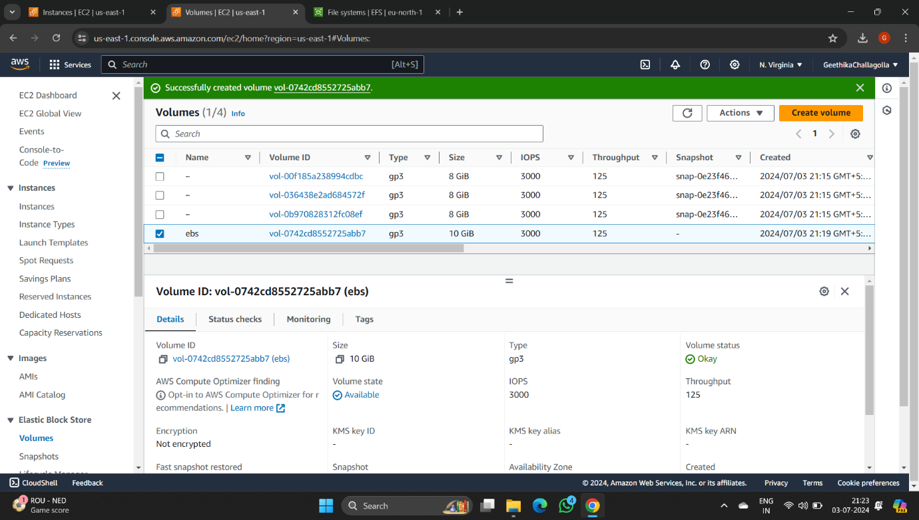

1. CHECK STORAGE

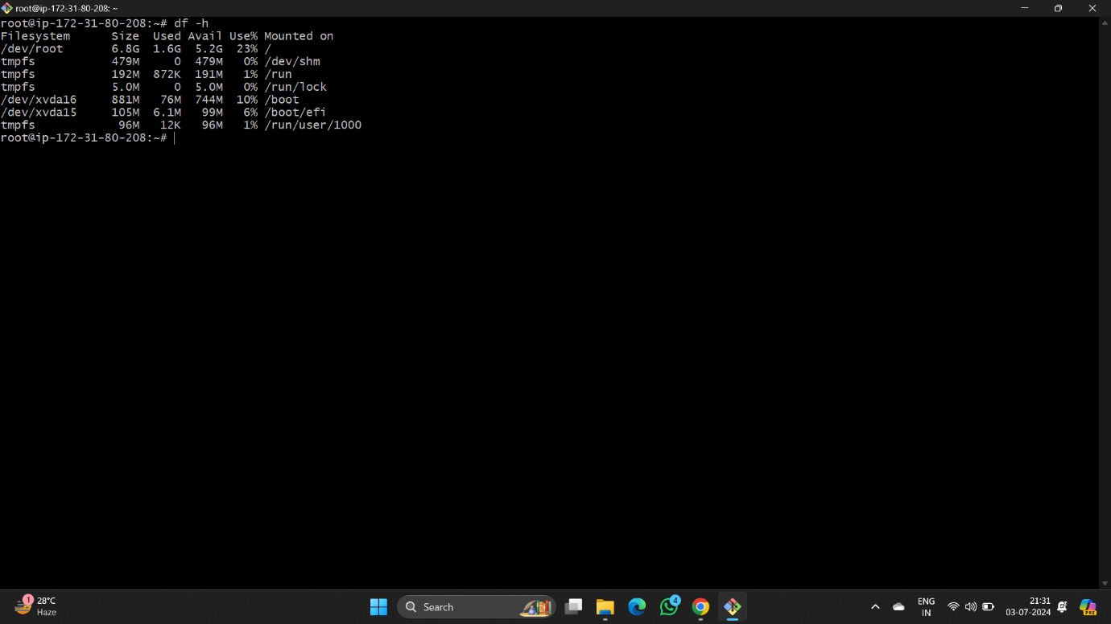

1. ATTACH INSTANCE TO VOLUME

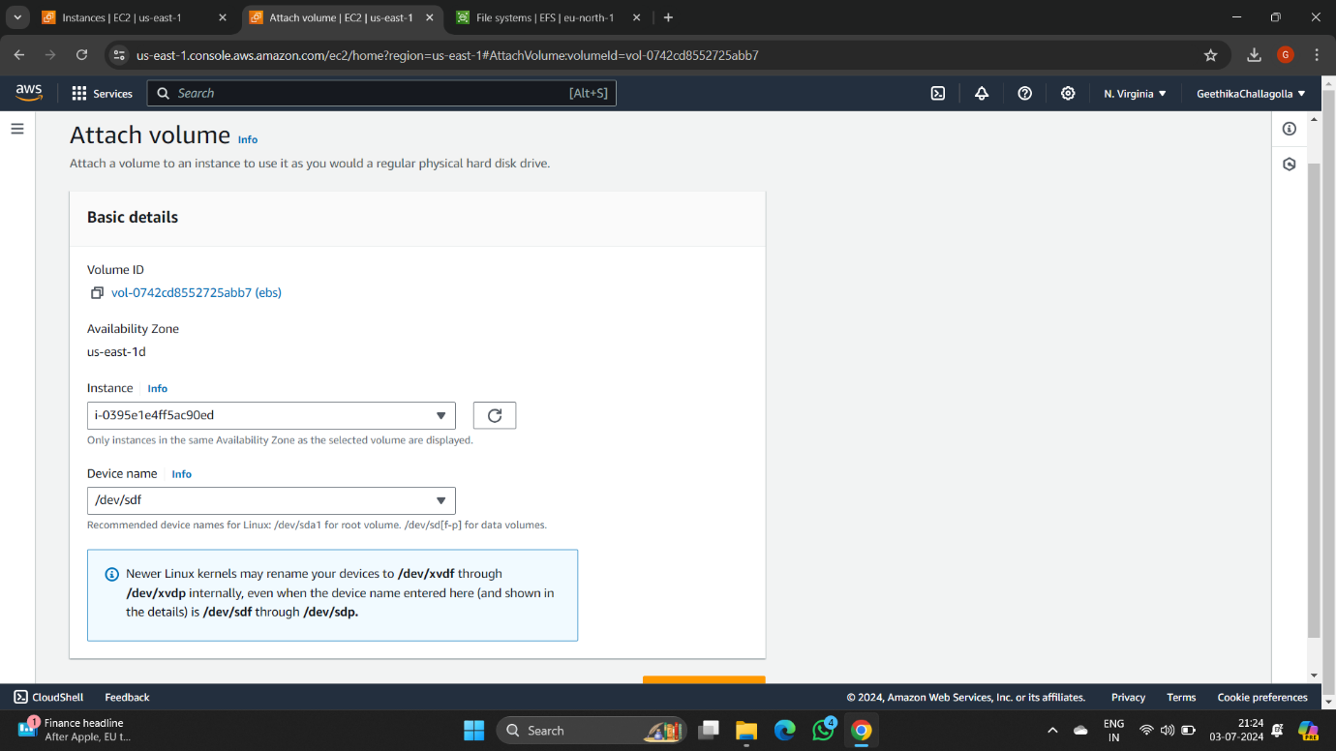

1. INSTANCE ATTACHED TO VOLUME

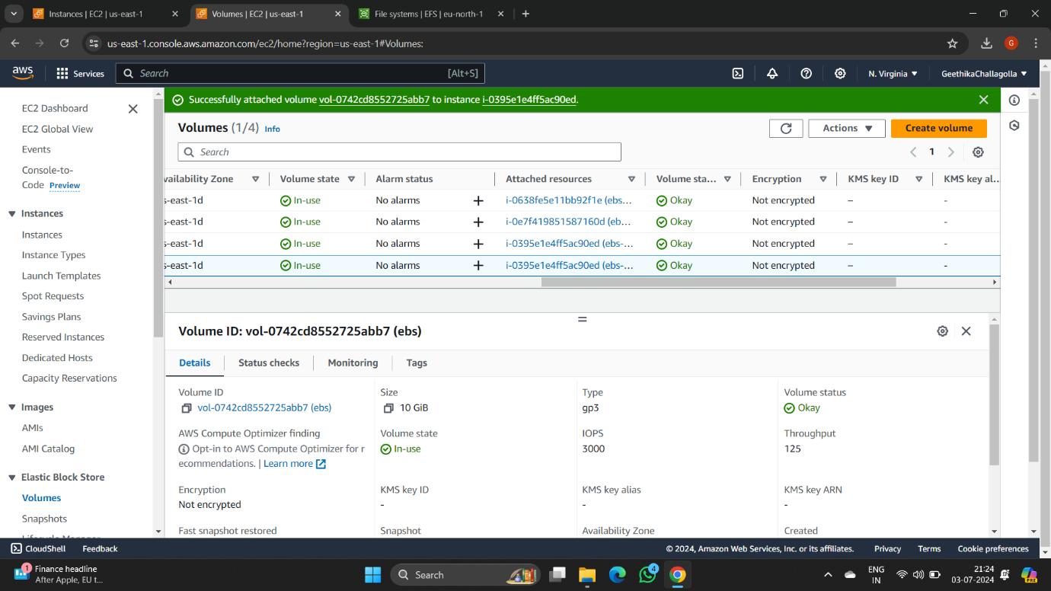

**EFS**

1. CREATE SECURITY GROUP

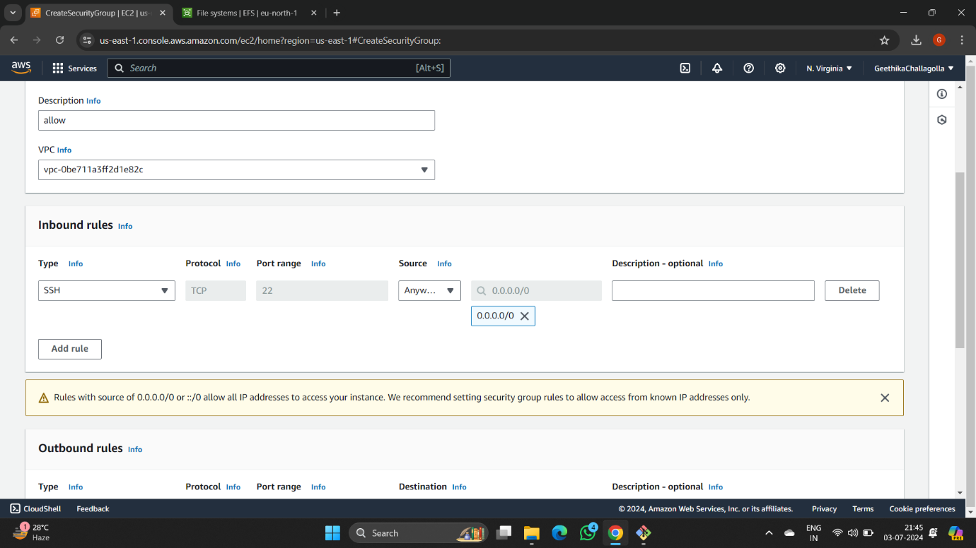

1. CREATE EFS,CREATE FILE SYSTEM

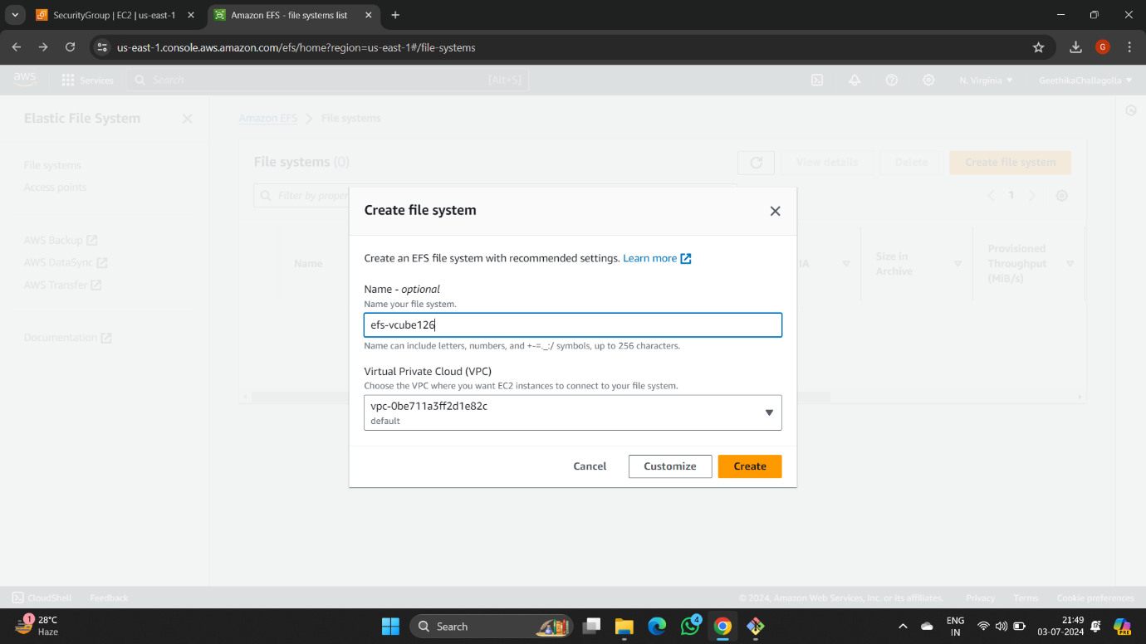

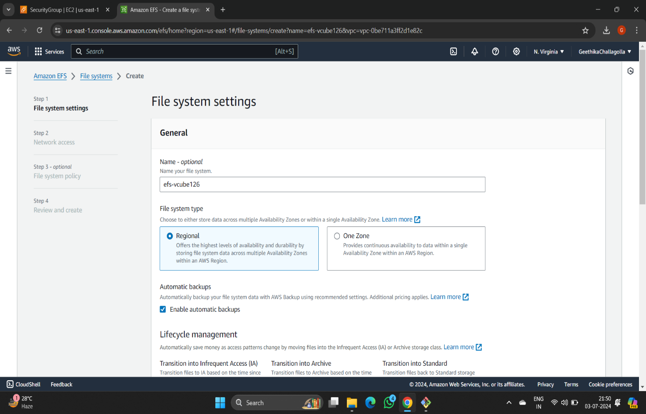

1. SELECT OWN SECURITY GROUP

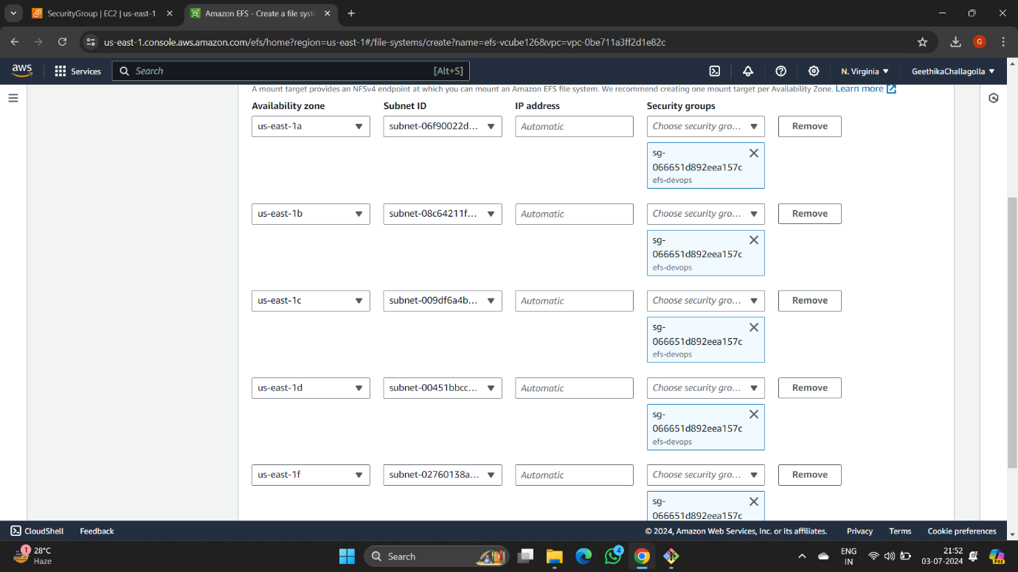

1. THE FILE SYSTEM IS CREATED

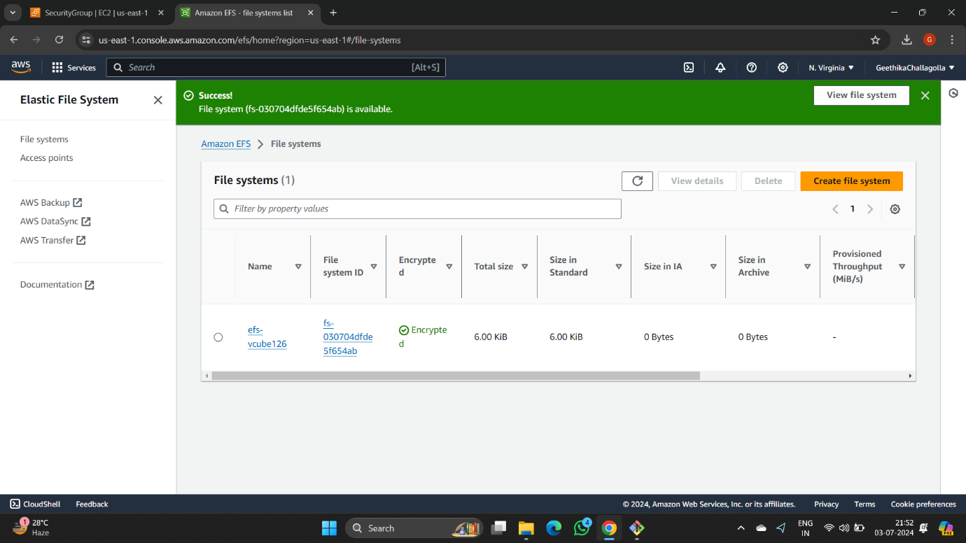

1. CREATE EC2 INSTANCES

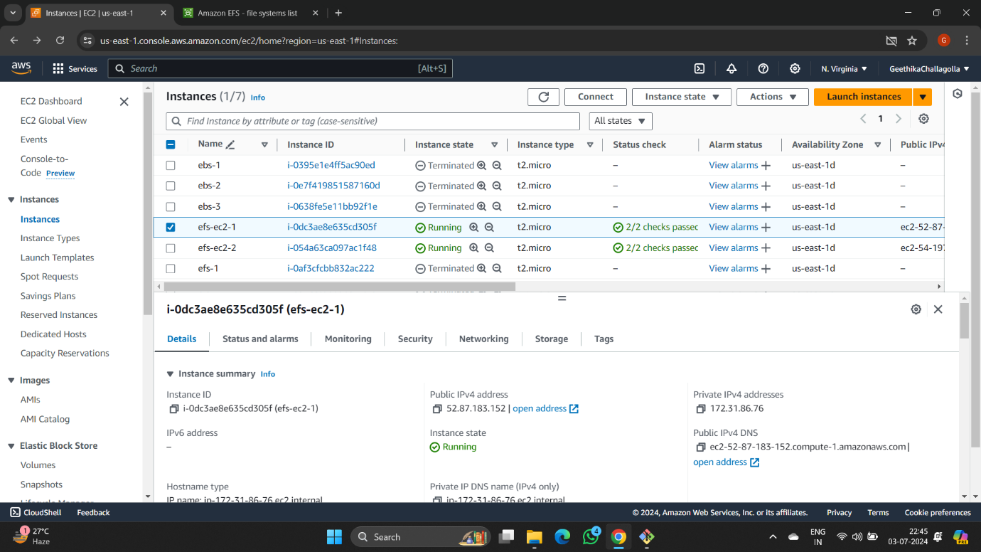

1. CREATING FILES IN EFS NAMED AS file1 FOR 2 INSTANCES

